**ECE 445**

Fall 2023

Team 13 Project Proposal

Tesla Coil Guitar Amp

Griffin Rzonca & David Mengel

TA Mentor: Jason Paximadas

**I. Introduction**

**Problem:**

Musicians are known for their affinity for flashy and creative displays and playing styles, especially during their live performances. One of the best ways to foster this creativity and allow artists to express themselves is a new type of amp that is both visually stunning and sonically interesting. Musical tesla coils have been used for performances in the past, showing there is a market for devices like this [1] . Though, these often use premade music files or are computer-controlled, and do not have the ability to take live input from instruments. Giving these coils the ability to take live input from a musician to create music would open up a new world of possibilities for musical expression and exciting live performances.

**Solution:**

Our design is a guitar amp that uses a tesla coil to create a unique tone and dazzling visuals to go along with it. The device will take the input from an electric guitar and use this to change the frequency of a tesla coil's sparks onto a grounding rod, creating a tone that matches that of the guitar.

**Visual Aid:**

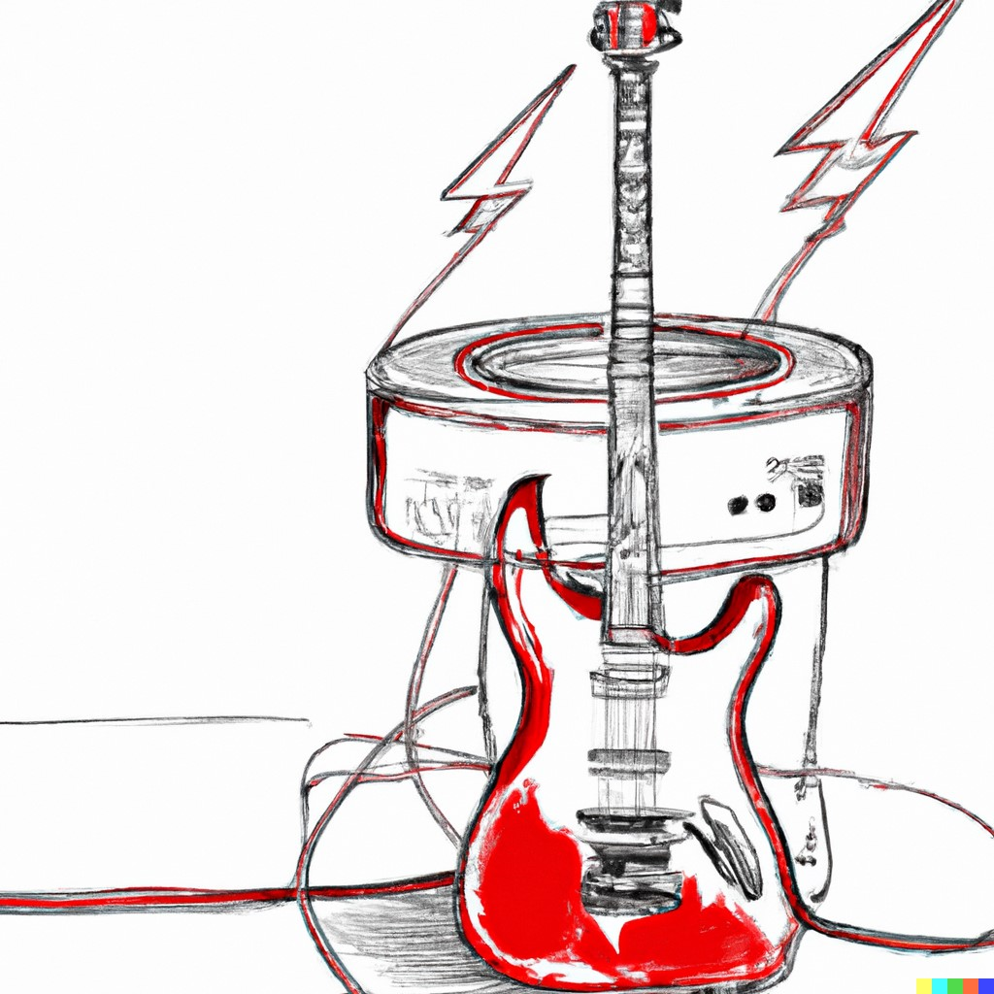

**High-Level Requirements:**

There are three primary requirements that this design must fulfill in order to be considered successful:

1. The tesla coil can produce visible sparks roughly 5cm in length
2. The coil can produce several different notes and tones
3. The coil can take input from the guitar to determine the notes played

**II. Design**

**Block Diagram:**

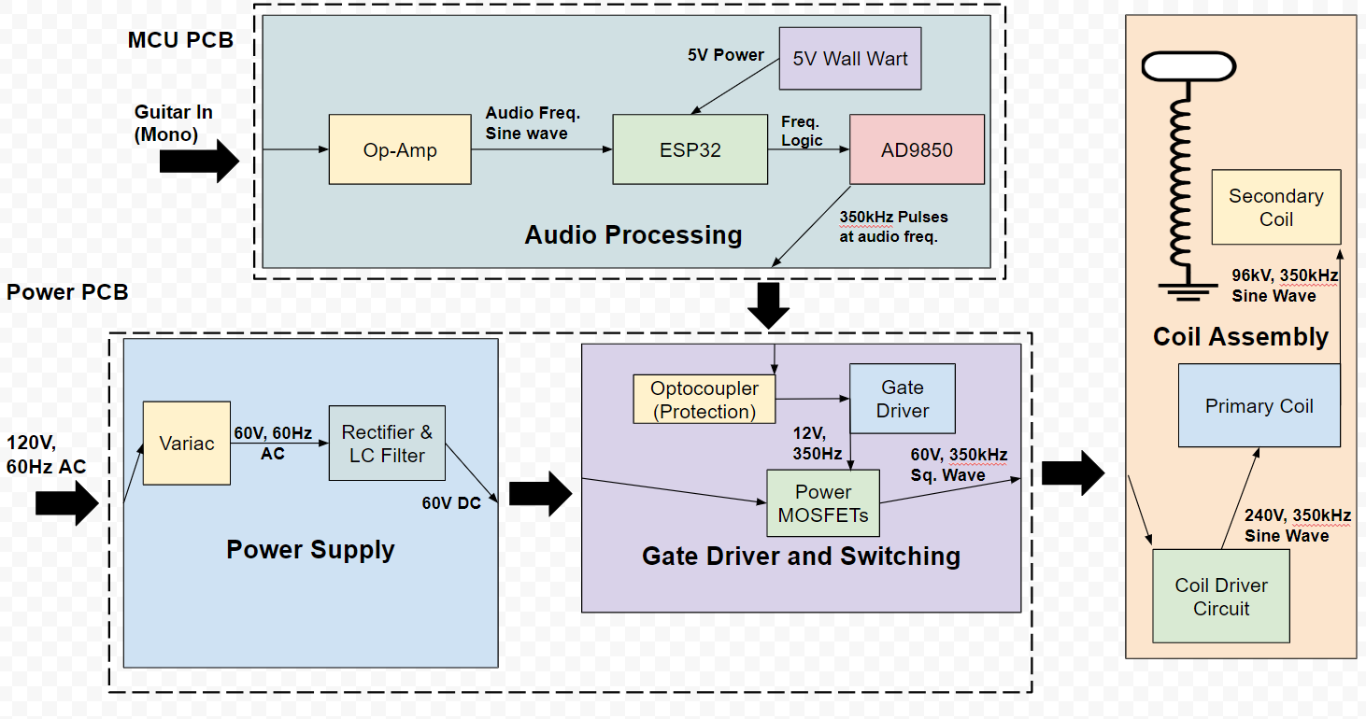

**Subsystem Overview & Subsystem Requirements:**

**Audio Processing:**

The audio processing system will convert the output of the guitar into a pulse wave to be fed as a driver for the tesla coil. This can be done using a network of op-amps. In order to operate our tesla coil, we need to drive it at its resonant frequency. Initial calculations and research have this value somewhere around 350kHz. We will use the ESP32 microcontroller and an AD9850 frequency generator in order to create signals at the resonant frequency. In order to output different notes, we will use pulses of the resonant frequency, with the pulses at the frequency of the desired note. We would like this frequency output to be within 10 Hz of the resonant frequency. For example, an A note corresponds to around 110Hz, so, to “play” an A note, the drivers will create pulses of the resonant frequency, with 110 pulses per second. This output will then be passed to the gate drivers.

*Requirements:*

* Microcontroller output variable pulse width wave with frequencies in the range 100-500 kHz with a tolerance of 10 Hz
* Microcontroller digital signal must be turned to analog to create audible sound and can be done with a digital to analog converter at a resolution of 10mV
* Output frequency must be able to reach the Tesla Coil Resonant Frequency (~350kHz)
* Audio processing unit must be able to produce the signals and waveforms needed to be communicated with the gate driver. This means output voltage level must be compatible with gate driver, unit must be able to produce pulses at resonant frequency of 350kHz if needed to drive coil, unit must be able to provide output that corresponds to acceptable output power of final coil
* Microcontroller needs to employ pulse-width modulation to create a square wave with predetermined amplitude and frequency

**Gate Drivers and Switching:**

This subsystem will take an input from the audio processing subsystem, send it through an optocoupler for signal isolation to protect the user, and then will send the signal to gate drivers, which will trigger the MOSFETs at pulses of the resonant frequency, with the pulse frequency corresponding to the frequency of the desired audio note. The gate drivers will use a 12V wall wart power supply to power the logic, and control the MOSFETs by outputting 10-12V between each FET’s gate and source. We will use the SI82394CD4-IS gate driver, because of its 12V output capabilities and the fact that it is isolated, which provides an additional layer of protection for the rest of the circuit from the 60V on the power rail.

The goal of the switching circuitry is to send a square wave to the coil assembly system. The switches will take the rectified DC voltage from the power subsystem and a turn-on signal from the gate drivers in order to operate. The switches will consist of two parallel branches of power MOSFETs to turn the 60V 60Hz input signal into a square wave at around 350kHz. We will use the Infineon STW65N65DM2AG due to its high current and voltage ratings of 60A and 650V, respectively. Its low resistance of around 50mΩ also allows us to minimize losses. The MOSFETs will be driven at the resonant frequency, calculated to be 357kHz according to the LtSpice simulation. The model of FET selected has a 13.5ns rise time and a 11.5ns fall time, with turn-on and turn-off delays of 33 and 114ns, respectively. These short delay times should be suitable for the intended driving frequency of around 350kHz.

*Requirements:*

* Transistors must be operable up to 100 volts.
* Transistors must be able to sink 20A of current
* Transistors must have switching bandwidth above resonant frequency of 350kHz
* Gate drivers must supply 12V to turn on transistors
* Gate drivers must be capable of switching above resonant frequency of 350kHz

**Power Supply:**

The power supply will take 120V AC mains from a wall outlet, step the voltage down to 60V using a Variac, and then rectify and filter this voltage to a DC voltage with minimal ripple. The filter will require large capacitors, which will have bleeder resistors to ensure that they can discharge so that the board is safe to work with.

The steady 60V DC signal will then be sent to the switching subsystem, where the power MOSFETs will convert this to a signal suitable for the coil.  
*Requirements:*

* Power supply must limit ripple to 10%, so ±6V ripple going into switching
* Limit current spikes into switching to 10A
* Power supply must output 60V or lower to switching subsystems.
* Power supply must not trip wall outlet circuit breakers, limiting power consumption to under 1kW (Breaker limit is 1.5kW[2])
* Capacitors must discharge after 2 minutes of the coil being disconnected from the wall

**Coil Assembly:**

The coil assembly is the medium that will output sparks at the desired frequency. The coil will consist of a few wire loops on the primary side and around 500 turns of copper wire on the secondary side in order to step up voltage for spark generation. The coil assembly can be small in size (~50 cm tall) for easy storage and transport. All sparks will be directed onto a grounded metal rod 3-5 cm from the coil. The coil will take input from the switching circuitry and its output will be in the form of sparks onto the grounding rod.

*Requirements:*

* Coil must output visible sparks
* All sparks must be directed onto the grounding rod, no arcing onto other components of the system
* The coil’s sparks must correspond to audio frequencies

**III. Tolerance Analysis:**

The most critical block in our diagram is the coil driving assembly. This assembly is a resonant circuit, which can be modeled as such:

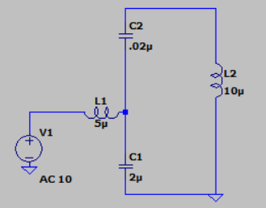

The AC input will be a pulse wave, generated by the MOSFET half-bridge connected to voltage rails. L7 is the primary winding of the tesla coil, estimated to be about 10 uH. The frequency response of this circuit is such that when

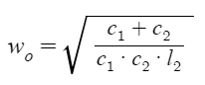 then: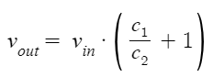

In addition, in this scenario, input current is 0. This means that in a lossless circuit, power consumption is 0, and this current just sloshes around the tank. Note that none of these values depend on the inductance of L1. This will become important in a moment. There are two practical concerns when implementing a circuit like this. The first is to do with the fact that the input signal is a square wave, not a sine wave, and the second has to do with parasitic resistances.

Note that if we pick the fundamental frequency as we do above, and have an inductance of 0 for L1, as we raise the frequency, the circuit will behave more and more like a short to the input. Thus, if we input a square wave into this circuit, the efficiency at the fundamental will be very high, but harmonic distortion will cause an extremely high DC current to come from the power source, all of which is wasted. This is where L1 comes into play. Note that in ideal circumstances, no matter what the value of L1, the voltage gain is the same, as is the input current (0) and the frequency with this property. If L1 is high (or at least non-zero), higher harmonics contained in the square wave just won’t pass through. In this way, input current will be very low.

The second consideration here is parasitic resistances. Due to these resistances, the input current isn’t really zero, and after L1 reaches a certain size, voltage gain becomes non ideal. The important part, though, is that all of these components have high tolerances for exact value. Resonant frequency should be calculated by the microcontroller. Basically, L1 can’t be too big, and the ESR for C1 and C2 should be as small as possible. Another consideration here is voltage tolerances for the capacitors. The capacitors can experience very high voltages, if for a short period of time. Thus, these capacitors must be able to manage at least 1kV AC voltage without breaking.

The inductors in this circuit will be hand wound, they’re only a couple of turns. They will also be handling high current, so thick wire must be used. This wire should be able to handle at least 100 amps of current without breaking. Due to the properties of this circuit, the tolerances of the MOSFETs can be a little more flexible. Current gain is astronomic, so in an ideal scenario, there could be no more than 30 amps, possibly much less flowing through the mosfets. They must be rated for this current level. These MOSFETS must also have DC blocking levels much higher than voltage rails, double would be preferable, so for 60V rails, that would mean a blocking voltage of around 120V. On resistance of mosfets is also less important with this circuit topology, because comparatively low current is flowing into the tank.

The most important tolerance to support this circuit, however, is the microcontroller's granularity of output. This circuit is extremely frequency dependent. Below is a frequency response curve of the tank circuit with l1 removed, and parasitic resistances included. Blue is current in, green is voltage out. Note how current in has a minimum at ~358 kHz, and a maximum at ~354 kHz. These extremes are alleviated slightly with the inclusion of l1, but still remain. With Q values this high, the microcontroller needs to be able to output a variable pulse width wave with frequencies in the range 100-500 kHz with granularity of ~10 hz. This is probably the most important specification of any element in our circuit.

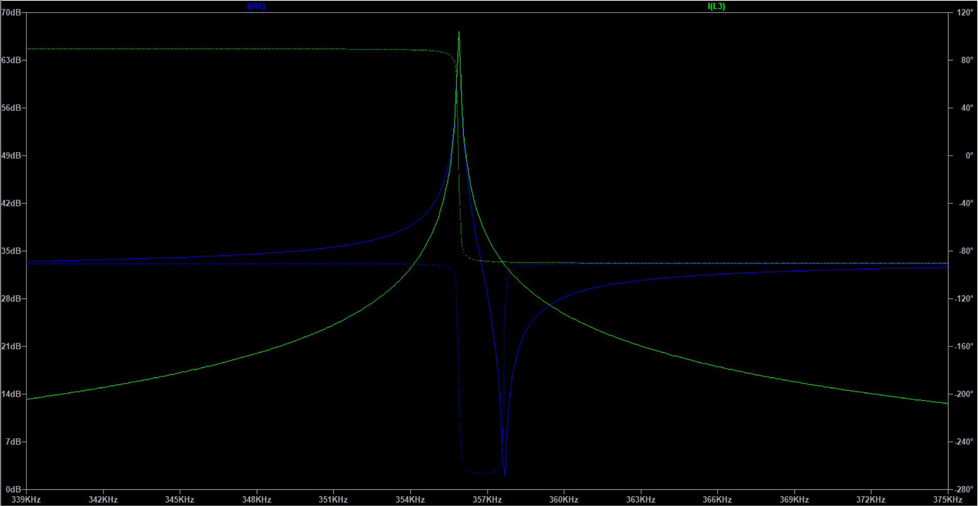

**IV. Ethics and Safety:**

**Ethics:**

Our group will act in accordance with the IEEE code of ethics. We understand that the technologies and parts that we are working with have the ability to affect one’s life. In our group, we have established a process to review and revise all software and hardware designs that will take everyone’s considerations into account. We will make sure to follow course guidelines for feedback and work with the head TA, Jason, closely. One ethical consideration that we need to take is not necessary with regards to our project, but with regards to making sure we treat everyone we work with with respect. We have taken steps to address this with open communication amongst our group members as well as our lead TA. Additionally, we have created a google drive with all of our research and design ideas, as that way everyone can access it and always give open feedback without the fear of their ideas not being taken into consideration. There aren’t too many ethical concerns with this project, but there are some concerns with the use cases of this project. We outlined that we expect this tesla coil to be used in a live music performance setting, and not in other industries such as the military. Other ethical concerns with this project involve user safety, however in the next section we outline our safety concerns and guidelines to make sure there is no harm or injuries.

**Safety:**

We have considered potential safety issues regarding the use and design of the Tesla Coil, and have outlined below precautions and safety measures that we will take in order to prevent any potential risks. We will be following the Safety Guidelines set on the ECE 445 web page, as we have already all completed the Safety Training, and all plan to complete the extra training that is required for working with high currents. We have looked at the previous group to make a Tesla Coil, and are incorporating safety measures they took as well.

* The tesla coil will never be turned on indoors, it will be tested outside with multiple group members present using an outdoor wall outlet, with cones to create a circle of safety to keep bystanders away.
* We will keep everyone at least 10 ft away while the coil is active.
* The voltage can reach up to 100kV (albeit low current) so all sparks will be directed onto a grounding rod 3-5 cm away, as a general rule of thumb is each 30kV can bridge a 1cm gap [3].
* The coil will have two fuses - one at the power supply and one after the filtering of the 60V DC bus.
* The cable from the guitar will use a phototransistor so that the user is not connected to a circuit with any power electronics.
* The gate drivers are isolated gate drivers with a blocking voltage around 2.5kV, providing extra protection.
* We will have a grounding rod, so that we can ground the tesla coil after use so that it will be safe to handle after grounding.
* In order to take extra precautions because we are working with high power and voltage, we will be using gloves when working with the Tesla Coil.

**V. Citations:**

[1] Long, Jason; et al. *Improving the Musical Expressiveness of Tesla Coils with Software.* 1 Oct 2015. Accessed 27 Sep 2023.

[2] Jones, Edwin; Wright, Andrew. *How Many Watts Can an Outlet Handle?* Galvin Power. 1 Sep 2023. Accessed 26 Sep 2023.

[3] Papiewski, John. *How to Calculate Voltage by Spark Gaps.* 13 Mar 2018. Accessed 26 Sep 2023.